Candlesticks?

A **candlestick** chart (also called Japanese **candlestick** chart) is a style of financial chart used to describe price movements of a security, derivative, or currency. Each "**candlestick**" typically shows one day; so for example a one-month chart may show the 20 **trading** days as 20 "**candlesticks**".

What you will learn

* How to read and Candlesticks
* A few Candlestick patterns I look for
* Why it’s important to use Candlesticks
* How to read Candlesticks

Well candlesticks are a visual way to represent data

Invented by the a.

They are a excellent way to indicate what other people are doing in the market and why, See trading can be like a game of chess with other traders reading why the other ones are doing what they are and seeing how you can capitalize off they mistakes.

Here is a diagram of the way candle sticks can be read

Then I will explain what each part means.

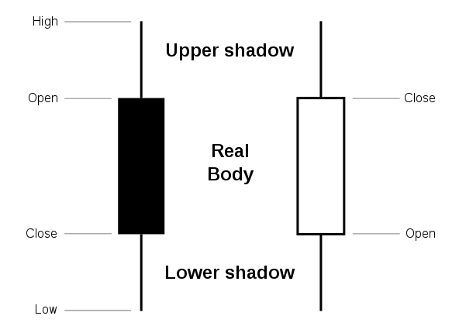

* Wick

This is the line above and below the body it represents the complete price movement history within the candlestick time frame .

* Body

This is the portion of the candlestick located in between the bottom of the top wick and the top of the bottom wick

It represents the price when the candlestick timeframe begins and when it ends. Bullish or Green in this case white are when the open price is below the close price

And bearish aka red or in this case black is when the candlestick opens at a higher price then it closes.

* Timeframe

Time frame is the width of each candle so if it’s 5min candlesticks it takes 5 minutes from the most recent candlestick for the new one to appear and in between that time all of the data is being collected to make the final version of the candlestick.

* Why is it important to use Candle sticks?

Well if your are just looking at a line price graph then it’s technically just an average of the price movement because there aren't candle wicks to show the little details in the price movement for example look at this chart

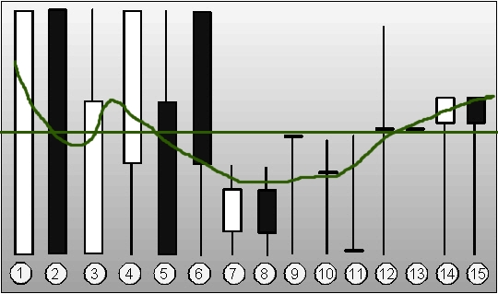

Notice how the price movement AVG isn't telling the whole story compared to the story that the Candlesticks do?

This is Because the green line is just a price moving average.

- Candlestick patterns 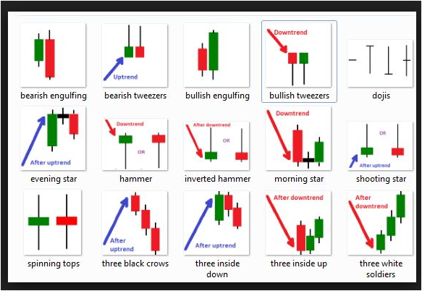

Remember bullish means a move up in price and bearish means a move down in price

* Summary

Candlesticks were invented by the japanese and are a much more effective way of seeing the way the market is moving

## **Formation**

**In order to create a candlestick chart, you must have a data set that contains open, high, low and close values for each time period you want to display. The hollow or filled portion of the candlestick is called “the body” (also referred to as “the real body”). The long thin lines above and below the body represent the high/low range and are called “shadows” (also referred to as “wicks” and “tails”). The high is marked by the top of the upper shadow and the low by the bottom of the lower shadow. If the stock closes higher than its opening price, a hollow candlestick is drawn with the bottom of the body representing the opening price and the top of the body representing the closing price. If the stock closes lower than its opening price, a filled candlestick is drawn with the top of the body representing the opening price and the bottom of the body representing the closing price.**

**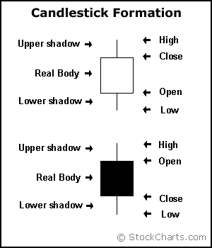**

**nCompared to traditional bar charts, many traders consider candlestick charts more visually appealing and easier to interpret. Each candlestick provides an easy-to-decipher picture of price action. Immediately a trader can compare the relationship between the open and close as well as the high and low. The relationship between the open and close is considered vital information and forms the essence of candlesticks. Hollow candlesticks, where the close is greater than the open, idicate buying pressure. Filled candlesticks, where the close is less than the open, indicate selling pressure.**

**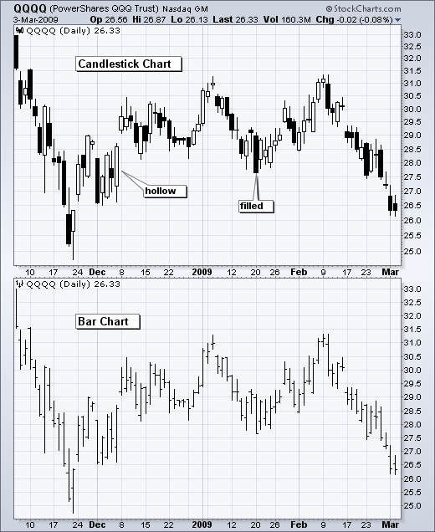**

## **Long Versus Short Bodies**

**Generally speaking, the longer the body is, the more intense the buying or selling pressure. Conversely, short candlesticks indicate little price movement and represent consolidation.**

**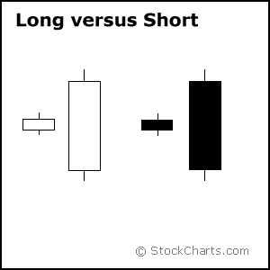**

**Long white candlesticks show strong buying pressure. The longer the white candlestick is, the further the close is above the open. This indicates that prices advanced significantly from open to close and buyers were aggressive. While long white candlesticks are generally bullish, much depends on their position within the broader technical picture. After extended declines, long white candlesticks can mark a potential turning point or** [**support**](http://stockcharts.com/school/doku.php?id=chart_school:glossary_s) **level. If buying gets too aggressive after a long advance, it can lead to excessive bullishness.**

**Long black candlesticks show strong selling pressure. The longer the black candlestick is, the further the close is below the open. This indicates that prices declined significantly from the open and sellers were aggressive. After a long advance, a long black candlestick can foreshadow a turning point or mark a future** [**resistance**](http://stockcharts.com/school/doku.php?id=chart_school:glossary_r) **level. After a long decline a long black candlestick can indicate panic or capitulation.**

**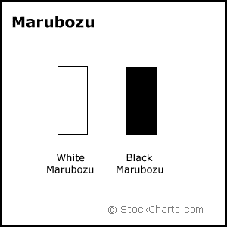**

**Even more potent long candlesticks are the Marubozu brothers, Black and White. Marubozu do not have upper or lower shadows and the high and low are represented by the open or close. A White Marubozu forms when the open equals the low and the close equals the high. This indicates that buyers controlled the price action from the first trade to the last trade. Black Marubozu form when the open equals the high and the close equals the low. This indicates that sellers controlled the price action from the first trade to the last trade.**

## **Long Versus Short Shadows**

**The upper and lower shadows on candlesticks can provide valuable information about the trading session. Upper shadows represent the session high and lower shadows the session low. Candlesticks with short shadows indicate that most of the trading action was confined near the open and close. Candlesticks with long shadows show that prices extended well past the open and close.**

**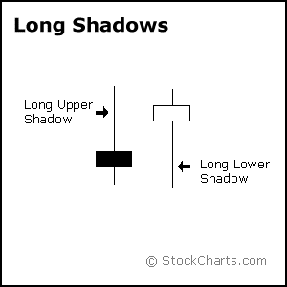**

**Candlesticks with a long upper shadow and short lower shadow indicate that buyers dominated during the session, and bid prices higher. However, sellers later forced prices down from their highs, and the weak close created a long upper shadow. Conversely, candlesticks with long lower shadows and short upper shadows indicate that sellers dominated during the session and drove prices lower. However, buyers later resurfaced to bid prices higher by the end of the session and the strong close created a long lower shadow.**

**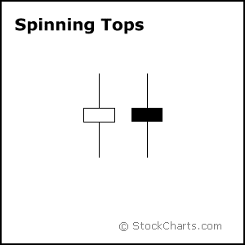**

**Candlesticks with a long upper shadow, long lower shadow and small real body are called spinning tops. One long shadow represents a reversal of sorts; spinning tops represent indecision. The small real body (whether hollow or filled) shows little movement from open to close, and the shadows indicate that both bulls and bears were active during the session. Even though the session opened and closed with little change, prices moved significantly higher and lower in the meantime. Neither buyers nor sellers could gain the upper hand and the result was a standoff. After a long advance or long white candlestick, a spinning top indicates weakness among the bulls and a potential change or interruption in trend. After a long decline or long black candlestick, a spinning top indicates weakness among the bears and a potential change or interruption in trend.**

## **Doji**

**Doji are important candlesticks that provide information on their own and as components of in a number of important patterns. Doji form when a security's open and close are virtually equal. The length of the upper and lower shadows can vary and the resulting candlestick looks like a cross, inverted cross or plus sign. Alone, doji are neutral patterns. Any bullish or bearish bias is based on preceding price action and future confirmation. The word “Doji” refers to both the singular and plural form.**

**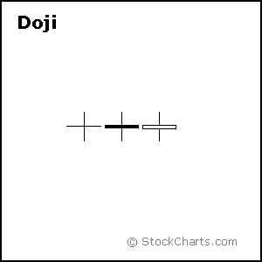**

**Ideally, but not necessarily, the open and close should be equal. While a doji with an equal open and close would be considered more robust, it is more important to capture the essence of the candlestick. Doji convey a sense of indecision or tug-of-war between buyers and sellers. Prices move above and below the opening level during the session, but close at or near the opening level. The result is a standoff. Neither bulls nor bears were able to gain control and a turning point could be developing.**

**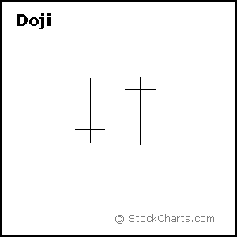**

**Different securities have different criteria for determining the robustness of a doji. A $20 stock could form a doji with a 1/8 point difference between open and close, while a $200 stock might form one with a 1 1/4 point difference. Determining the robustness of the doji will depend on the price, recent volatility, and previous candlesticks. Relative to previous candlesticks, the doji should have a very small body that appears as a thin line. Steven Nison notes that a doji that forms among other candlesticks with small real bodies would not be considered important. However, a doji that forms among candlesticks with long real bodies would be deemed significant.**

### **Doji and Trend**

**The relevance of a doji depends on the preceding trend or preceding candlesticks. After an advance, or long white candlestick, a doji signals that the buying pressure is starting to weaken. After a decline, or long black candlestick, a doji signals that selling pressure is starting to diminish. Doji indicate that the forces of supply and demand are becoming more evenly matched and a change in trend may be near. Doji alone are not enough to mark a reversal and further confirmation may be warranted.**

**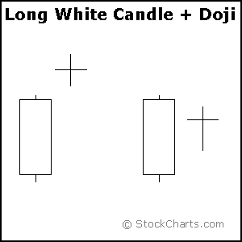**

**After an advance or long white candlestick, a doji signals that buying pressure may be diminishing and the uptrend could be nearing an end. Whereas a security can decline simply from a lack of buyers, continued buying pressure is required to sustain an uptrend. Therefore, a doji may be more significant after an uptrend or long white candlestick. Even after the doji forms, further downside is required for bearish confirmation. This may come as a gap down, long black candlestick, or decline below the long white candlestick's open. After a long white candlestick and doji, traders should be on the alert for a potential evening doji star.**

**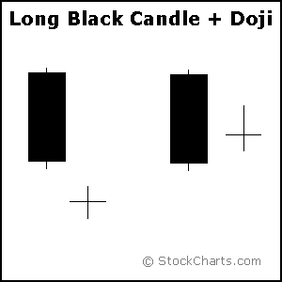**

**After a decline or long black candlestick, a doji indicates that selling pressure may be diminishing and the downtrend could be nearing an end. Even though the bears are starting to lose control of the decline, further strength is required to confirm any reversal. Bullish confirmation could come from a gap up, long white candlestick or advance above the long black candlestick's open. After a long black candlestick and doji, traders should be on the alert for a potential morning doji star.**

### **Long-Legged Doji**

**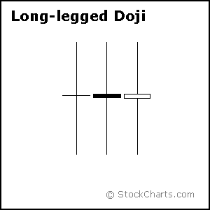**

**Long-legged doji have long upper and lower shadows that are almost equal in length. These doji reflect a great amount of indecision in the market. Long-legged doji indicate that prices traded well above and below the session's opening level, but closed virtually even with the open. After a whole lot of yelling and screaming, the end result showed little change from the initial open.**

### **Dragonfly and Gravestone Doji**

**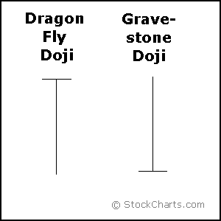**

#### **Dragonfly Doji**

**Dragonfly doji form when the open, high and close are equal and the low creates a long lower shadow. The resulting candlestick looks like a “T” with a long lower shadow and no upper shadow. Dragonfly doji indicate that sellers dominated trading and drove prices lower during the session. By the end of the session, buyers resurfaced and pushed prices back to the opening level and the session high.**

**The reversal implications of a dragonfly doji depend on previous price action and future confirmation. The long lower shadow provides evidence of buying pressure, but the low indicates that plenty of sellers still loom. After a long downtrend, long black candlestick, or at** [**support**](http://stockcharts.com/school/doku.php?id=chart_school:glossary_s)**, a dragonfly doji could signal a potential bullish reversal or bottom. After a long uptrend, long white candlestick or at** [**resistance**](http://stockcharts.com/school/doku.php?id=chart_school:glossary_r)**, the long lower shadow could foreshadow a potential bearish reversal or top. Bearish or bullish confirmation is required for both situations.**

#### **Gravestone Doji**

**Gravestone doji form when the open, low and close are equal and the high creates a long upper shadow. The resulting candlestick looks like an upside down “T” with a long upper shadow and no lower shadow. Gravestone doji indicate that buyers dominated trading and drove prices higher during the session. However, by the end of the session, sellers resurfaced and pushed prices back to the opening level and the session low.**

**As with the dragonfly doji and other candlesticks, the reversal implications of gravestone doji depend on previous price action and future confirmation. Even though the long upper shadow indicates a failed rally, the intraday high provides evidence of some buying pressure. After a long downtrend, long black candlestick, or at support, focus turns to the evidence of buying pressure and a potential bullish reversal. After a long uptrend, long white candlestick or at resistance, focus turns to the failed rally and a potential bearish reversal. Bearish or bullish confirmation is required for both situations.**

**Before turning to the single and multiple candlestick patterns, there are a few general guidelines to cover.**

## **Bulls Versus Bears**

**A candlestick depicts the battle between Bulls (buyers) and Bears (sellers) over a given period of time. An analogy to this battle can be made between two football teams, which we can also call the Bulls and the Bears. The bottom (intra-session low) of the candlestick represents a touchdown for the Bears and the top (intra-session high) a touchdown for the Bulls. The closer the close is to the high, the closer the Bulls are to a touchdown. The closer the close is to the low, the closer the Bears are to a touchdown. While there are many variations, I have narrowed the field to 6 types of games (or candlesticks):**

**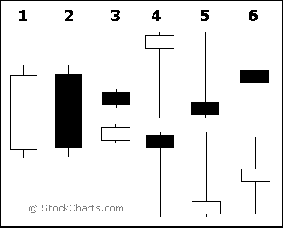**

1. ***Long white candlesticks* indicate that the Bulls controlled the ball (trading) for most of the game.**
2. ***Long black candlesticks* indicate that the Bears controlled the ball (trading) for most of the game.**
3. ***Small candlesticks* indicate that neither team could move the ball and prices finished about where they started.**
4. **A *long lower shadow* indicates that the Bears controlled the ball for part of the game, but lost control by the end and the Bulls made an impressive comeback.**
5. **A *long upper shadow* indicates that the Bulls controlled the ball for part of the game, but lost control by the end and the Bears made an impressive comeback.**
6. **A *long upper and lower shadow* indicates that the both the Bears and the Bulls had their moments during the game, but neither could put the other away, resulting in a standoff.**

## **What Candlesticks Don't Tell You**

**Candlesticks do not reflect the sequence of events between the open and close, only the relationship between the open and the close. The high and the low are obvious and indisputable, but candlesticks (and bar charts) cannot tell us which came first.**

**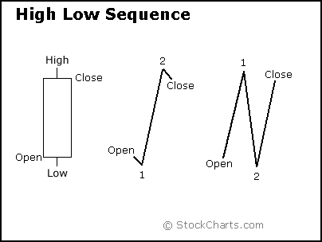**

**With a long white candlestick, the assumption is that prices advanced most of the session. However, based on the high/low sequence, the session could have been more** [**volatile**](http://stockcharts.com/school/doku.php?id=chart_school:glossary_v)**. The example above depicts two possible high/low sequences that would form the same candlestick. The first sequence shows two small moves and one large move: a small decline off the open to form the low, a sharp advance to form the high, and a small decline to form the close. The second sequence shows three rather sharp moves: a sharp advance off the open to form the high, a sharp decline to form the low, and a sharp advance to form the close. The first sequence portrays strong, sustained buying pressure, and would be considered more bullish. The second sequence reflects more volatility and some selling pressure. These are just two examples, and there are hundreds of potential combinations that could result in the same candlestick. Candlesticks still offer valuable information on the relative positions of the open, high, low and close. However, the trading activity that forms a particular candlestick can vary.**

## **Prior Trend**

**In his book,** [***Candlestick Charting Explained***](http://store.stockcharts.com/products/candlestick-charting-explained-3rd-edition)**, Greg Morris notes that for a pattern to qualify as a reversal pattern, there should be a prior trend to reverse. Bullish reversals require a preceding downtrend and bearish reversals require a prior uptrend. The direction of the trend can be determined using** [**trend lines**](http://stockcharts.com/school/doku.php?id=chart_school:glossary_t)**,** [**moving averages**](http://stockcharts.com/school/doku.php?id=chart_school:glossary_m)**, peak/trough analysis or other aspects of technical analysis. A downtrend might exist as long as the security was trading below its down trend line, below its previous** [**reaction high**](http://stockcharts.com/school/doku.php?id=chart_school:glossary_r) **or below a specific moving average. The length and duration will depend on individual preferences. However, because candlesticks are short-term in nature, it is usually best to consider the last 1-4 weeks of price action.**

## **Candlestick PositioningStar Position Candlestick example from StockCharts.com**

### **Star Position**

**A candlestick that gaps away from the previous candlestick is said to be in star position. The first candlestick usually has a large real body, but not always, and the second candlestick in star position has a small real body. Depending on the previous candlestick, the star position candlestick** [**gaps up or down**](http://stockcharts.com/school/doku.php?id=chart_school:glossary_g) **and appears isolated from previous price action. The two candlesticks can be any combination of white and black.** [**Doji**](http://stockcharts.com/school/doku.php?id=chart_school:glossary_d)**,** [**hammers**](http://stockcharts.com/school/doku.php?id=chart_school:glossary_h)**,** [**shooting stars**](http://stockcharts.com/school/doku.php?id=chart_school:glossary_s) **and spinning tops have small real bodies, and can form in the star position. Later we will examine 2- and 3-candlestick patterns that utilize the star position.**

**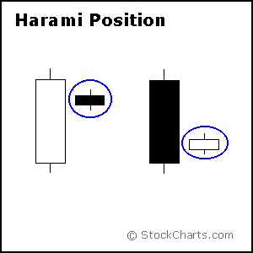**

### **Harami Position**

**A candlestick that forms within the real body of the previous candlestick is in Harami position. Harami means pregnant in Japanese and the second candlestick is nestled inside the first. The first candlestick usually has a large real body and the second a smaller real body than the first. The shadows (high/low) of the second candlestick do not have to be contained within the first, though it's preferable if they are. Doji and spinning tops have small real bodies, and can form in the harami position as well. Later we will examine candlestick patterns that utilize the harami position.**

## **Long Shadow Reversals**

**There are two pairs of single candlestick reversal patterns made up of a small real body, one long shadow and one short or non-existent shadow. Generally, the long shadow should be at least twice the length of the real body, which can be either black or white. The location of the long shadow and preceding price action determine the classification.**

**The first pair, Hammer and Hanging Man, consists of identical candlesticks with small bodies and long lower shadows. The second pair, Shooting Star and Inverted Hammer, also contains identical candlesticks, except, in this case, they have small bodies and long upper shadows. Only preceding price action and further confirmation determine the bullish or bearish nature of these candlesticks. The Hammer and Inverted Hammer form after a decline and are bullish reversal patterns, while the Shooting Star and Hanging Man form after an advance and are bearish reversal patterns.**

### **Hammer and Hanging Man**

**The Hammer and Hanging Man look exactly alike, but have different implications based on the preceding price action. Both have small real bodies (black or white), long lower shadows and short or non-existent upper shadows. As with most single and double candlestick formations, the Hammer and Hanging Man require confirmation before action.**

**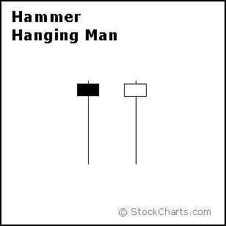**

**The Hammer is a bullish reversal pattern that forms after a decline. In addition to a potential trend reversal, hammers can mark bottoms or** [**support**](http://stockcharts.com/school/doku.php?id=chart_school:glossary_s) **levels. After a decline, hammers signal a bullish revival. The low of the long lower shadow implies that sellers drove prices lower during the session. However, the strong finish indicates that buyers regained their footing to end the session on a strong note. While this may seem enough to act on, hammers require further bullish confirmation. The low of the hammer shows that plenty of sellers remain. Further buying pressure, and preferably on expanding** [**volume**](http://stockcharts.com/school/doku.php?id=chart_school:glossary_v)**, is needed before acting. Such confirmation could come from a** [**gap up**](http://stockcharts.com/school/doku.php?id=chart_school:glossary_g) **or long white candlestick. Hammers are similar to selling climaxes, and heavy volume can serve to reinforce the validity of the reversal.**

**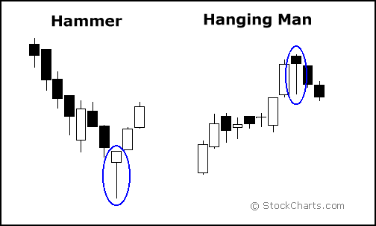**

**The Hanging Man is a bearish reversal pattern that can also mark a top or** [**resistance**](http://stockcharts.com/school/doku.php?id=chart_school:glossary_r) **level. Forming after an advance, a Hanging Man signals that selling pressure is starting to increase. The low of the long lower shadow confirms that sellers pushed prices lower during the session. Even though the bulls regained their footing and drove prices higher by the finish, the appearance of selling pressure raises the yellow flag. As with the Hammer, a Hanging Man requires bearish confirmation before action. Such confirmation can come as a gap down or long black candlestick on heavy volume.**

### **Inverted Hammer and Shooting Star**

**The Inverted Hammer and Shooting Star look exactly alike, but have different implications based on previous price action. Both candlesticks have small real bodies (black or white), long upper shadows and small or nonexistent lower shadows. These candlesticks mark potential trend reversals, but require confirmation before action.**

**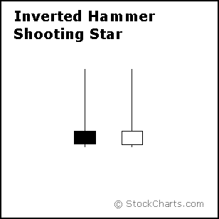**

**The Shooting Star is a bearish reversal pattern that forms after an advance and in the star position, hence its name. A Shooting Star can mark a potential trend reversal or resistance level. The candlestick forms when prices gap higher on the open, advance during the session and close well off their highs. The resulting candlestick has a long upper shadow and small black or white body. After a large advance (the upper shadow), the ability of the bears to force prices down raises the yellow flag. To indicate a substantial reversal, the upper shadow should relatively long and at least 2 times the length of the body. Bearish confirmation is required after the Shooting Star and can take the form of a gap down or long black candlestick on heavy volume.**

**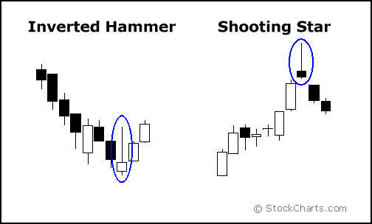**

**The Inverted Hammer looks exactly like a Shooting Star, but forms after a decline or downtrend. Inverted Hammers represent a potential trend reversal or support levels. After a decline, the long upper shadow indicates buying pressure during the session. However, the bulls were not able to sustain this buying pressure and prices closed well off of their highs to create the long upper shadow. Because of this failure, bullish confirmation is required before action. An Inverted Hammer followed by a gap up or long white candlestick with heavy volume could act as bullish confirmation.**

## **Blending Candlesticks**

**Candlestick patterns are made up of one or more candlesticks and can be blended together to form one candlestick. This blended candlestick captures the essence of the pattern and can be formed using the following:**

* **The open of first candlestick**
* **The close of the last candlestick**
* **The high and low of the pattern**

**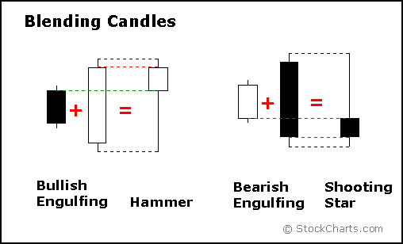**

**By using the open of the first candlestick, close of the second candlestick, and high/low of the pattern, a** [**Bullish Engulfing Pattern**](http://stockcharts.com/school/doku.php?id=chart_school:glossary_b) **or** [**Piercing Pattern**](http://stockcharts.com/school/doku.php?id=chart_school:glossary_p) **blends into a** [**Hammer**](http://stockcharts.com/school/doku.php?id=chart_school:glossary_h)**. The long lower shadow of the Hammer signals a potential bullish reversal. As with the Hammer, both the Bullish Engulfing Pattern and the Piercing Pattern require bullish confirmation.**

**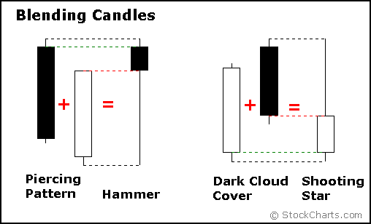**

**Blending the candlesticks of a** [**Bearish Engulfing Pattern**](http://stockcharts.com/school/doku.php?id=chart_school:glossary_b) **or** [**Dark Cloud Cover**](http://stockcharts.com/school/doku.php?id=chart_school:glossary_d) **Pattern creates a Shooting Star. The long, upper shadow of the Shooting Star indicates a potential bearish reversal. As with the Shooting Star, Bearish Engulfing, and Dark Cloud Cover Patterns require bearish confirmation.**

**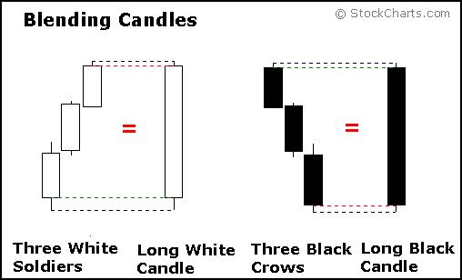**

**More than two candlesticks can be blended using the same guidelines: open from the first, close from the last and high/low of the pattern. Blending** [**Three White Soldiers**](http://stockcharts.com/school/doku.php?id=chart_school:glossary_t) **creates a long white candlestick and blending** [**Three Black Crows**](http://stockcharts.com/school/doku.php?id=chart_school:glossary_t) **creates a long black candlestick.**

* **TECHNICAL ANALYSIS IN ACTION**
* **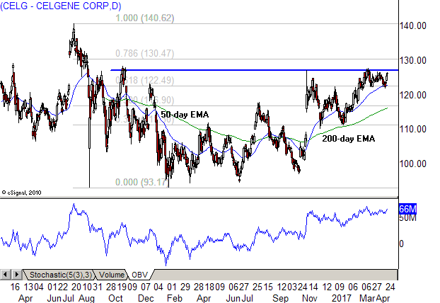[Time for Big Cap Biotech (CELG, VRTX)](http://www.investopedia.com/news/time-big-cap-biotech-celg-vrtx/)**
* **[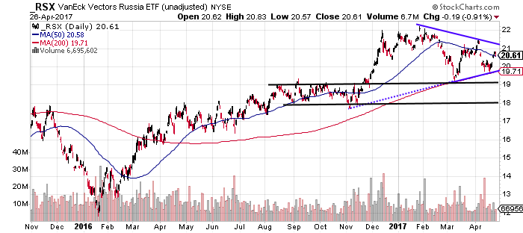](http://www.investopedia.com/news/time-big-cap-biotech-celg-vrtx/)[Russian Stocks Heading Toward Breakout Levels (RSX, RSXJ)](http://www.investopedia.com/news/russian-stocks-heading-toward-breakout-levels-rsx-rsxj/)**
* **[](http://www.investopedia.com/news/russian-stocks-heading-toward-breakout-levels-rsx-rsxj/)[Where is Netflix Headed from Here? (NFLX, BIDU)](http://www.investopedia.com/news/where-netflix-headed-here-nflx-bidu/)**
* **[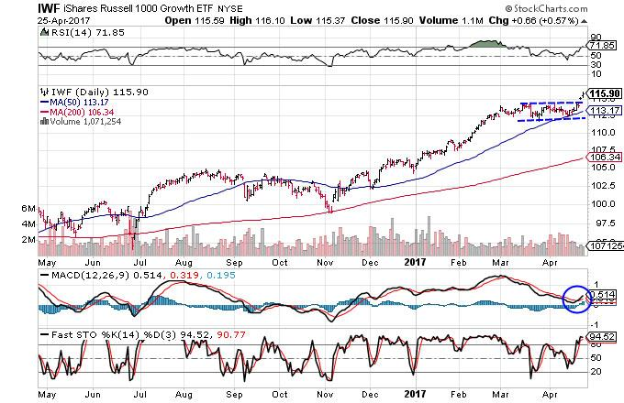](http://www.investopedia.com/news/where-netflix-headed-here-nflx-bidu/)[3 ETFs to Trade the Breakout in Value Stocks (IWF)](http://www.investopedia.com/news/3-etfs-trade-breakout-value-stocks-iwf/)**

[**Candlestick**](http://www.investopedia.com/terms/c/candlestick.asp) **charts are a technical tool that pack data for multiple time frames into single** [**price bars**](http://www.investopedia.com/terms/b/barchart.asp)**. This makes them more useful than traditional open-high, low-close bars (**[**OHLC**](http://www.investopedia.com/terms/o/ohlcchart.asp)**)​ or simple lines that connect the dots of** [**closing prices**](http://www.investopedia.com/terms/c/closingprice.asp)**. Candlesticks build patterns that predict** [**price direction**](http://www.investopedia.com/terms/t/trend.asp) **once completed. Proper color coding adds depth to this colorful technical tool, which dates back to 18th century Japanese rice** [**traders**](http://www.investopedia.com/terms/t/trader.asp)**.**

**Steve Nison brought candlestick patterns to the Western world in his popular 1991 book, "Japanese Candlestick Charting Techniques." Many traders can now identify dozens of these formations, which have colorful names like** [**bearish dark cloud cover**](http://www.investopedia.com/terms/d/darkcloud.asp)**,** [**evening star**](http://www.investopedia.com/terms/e/eveningstar.asp) **and** [**three black crows**](http://www.investopedia.com/terms/t/three_black_crows.asp)**. In addition, single bar patterns including the** [**doji**](http://www.investopedia.com/terms/d/doji.asp) **and** [**hammer**](http://www.investopedia.com/terms/h/hammer.asp) **have been incorporated into dozens of long- and short-side** [**trading strategies**](http://www.investopedia.com/terms/t/trading-strategy.asp)**. (For related reading, see** [***Candlestick Charting: What Is It?***](http://www.investopedia.com/articles/technical/02/121702.asp)**)**

## **Candlestick Pattern Reliability**

**Not all candlestick patterns work equally well. Their huge popularity has lowered reliability because they've been deconstructed by** [**hedge funds**](http://www.investopedia.com/terms/h/hedgefund.asp) **and their** [**algorithms**](http://www.investopedia.com/terms/a/algorithm.asp)**. These well-funded players rely on lightning-speed execution to trade against retail and traditional** [**fund managers**](http://www.investopedia.com/terms/f/fundmanager.asp) **who execute** [**technical analysis**](http://www.investopedia.com/terms/t/technicalanalysis.asp) **strategies found in popular texts. In other words,** [**hedge fund managers**](http://www.investopedia.com/terms/h/hedge-fund-manager.asp) **use software to trap participants looking for high-odds** [**bullish**](http://www.investopedia.com/terms/b/bull.asp) **or** [**bearish**](http://www.investopedia.com/terms/b/bear.asp) **outcomes. However, reliable patterns continue to appear, allowing for short- and long-term** [**profit**](http://www.investopedia.com/terms/p/profit.asp) **opportunities. (See also:** [***The Multiple Strategies of Hedge Funds***](http://www.investopedia.com/articles/investing/111313/multiple-strategies-hedge-funds.asp)**.)**

**Here are five candlestick patterns that perform exceptionally well as precursors of price direction and** [**momentum**](http://www.investopedia.com/terms/m/momentum.asp)**. Each works within the context of surrounding price bars in predicting higher or lower prices. They are also time sensitive in two ways. First, they only work within the limitations of the chart being reviewed, whether** [**intraday**](http://www.investopedia.com/terms/i/intraday.asp)**, daily, weekly or monthly. Second, their potency decreases rapidly three to five bars after the pattern has completed.**

## **Top 5 Candlestick Patterns**

**This analysis relies on the work of Thomas Bulkowski, who built performance rankings for candlestick patterns in his 2008 book, "Encyclopedia of Candlestick Charts." He offers statistics for two kinds of expected pattern outcomes:** [**reversal**](http://www.investopedia.com/terms/r/reversal.asp) **and** [**continuation**](http://www.investopedia.com/terms/c/continuationpattern.asp)**. Candlestick reversal patterns predict a change in price direction, while continuation patterns predict an extension in the** [**current price**](http://www.investopedia.com/terms/c/currentprice.asp) **direction.**

**In the following examples, the hollow** [**white candlestick**](http://www.investopedia.com/terms/w/white_candlestick.asp) **denotes a closing print higher than the opening print, while the black candlestick denotes a closing print lower than the opening print. (See** [***The Basic Language of Candlestick Charting***](http://www.investopedia.com/articles/technical/03/020503.asp) **for more information.)**

## **Three Line Strike**

**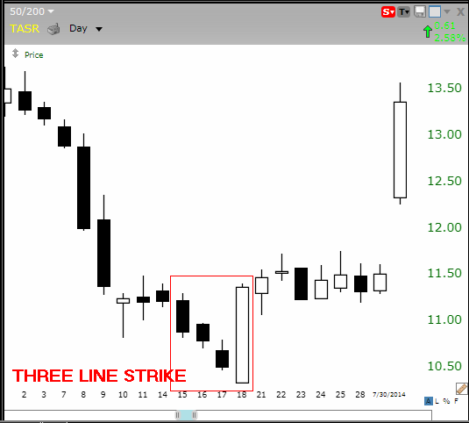**

**The bullish three line strike reversal pattern carves out three black candles within a** [**downtrend**](http://www.investopedia.com/terms/d/downtrend.asp)**. Each bar posts a lower low and closes near the intrabar low. The fourth bar opens even lower but reverses in a** [**wide-range**](http://www.investopedia.com/terms/w/wide-ranging-days.asp) **outside bar that closes above the high of the first candle in the series. The opening print also marks the low of the fourth bar. According to Bulkowski, this reversal predicts higher prices with an 84% accuracy rate.**

## **Two Black Gapping**

**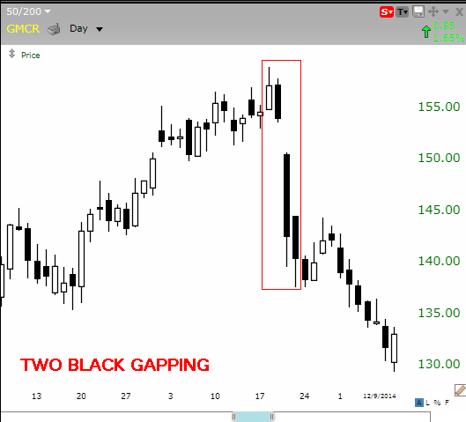**

**The bearish two black** [**gapping**](http://www.investopedia.com/terms/g/gapping.asp) **continuation pattern appears after a notable** [**top**](http://www.investopedia.com/terms/d/doubletop.asp) **in an uptrend, with a** [**gap**](http://www.investopedia.com/terms/g/gap.asp) **down that yields two black bars posting lower lows. This pattern predicts that the decline will continue to even lower lows, perhaps triggering a broader-scale downtrend. According to Bulkowski, this pattern predicts lower prices with a 68% accuracy rate.**

## **Three Black Crows**

**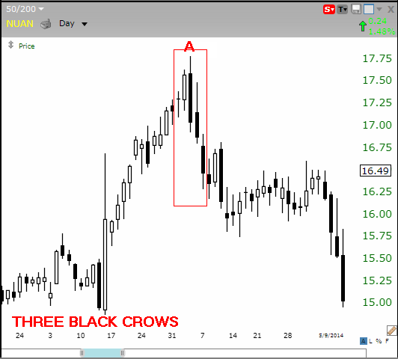**

**The bearish three black crows reversal pattern starts at or near the high of an uptrend, with three black bars posting lower lows that close near intrabar lows. This pattern predicts that the decline will continue to even lower lows, perhaps triggering a broader-scale downtrend. The most bearish version starts at a new high (point A on the chart) because it traps buyers entering** [**momentum**](http://www.investopedia.com/terms/m/momentum.asp) **plays. According to Bulkowski, this pattern predicts lower prices with a 78% accuracy rate. (For related reading, see** [***How Do I Build a Profitable Trading Strategy When Spotting a Three Black Crows Pattern?***](http://www.investopedia.com/ask/answers/012815/how-do-i-build-profitable-strategy-when-spotting-three-black-crows-pattern.asp)**)**

## **Evening Star**

**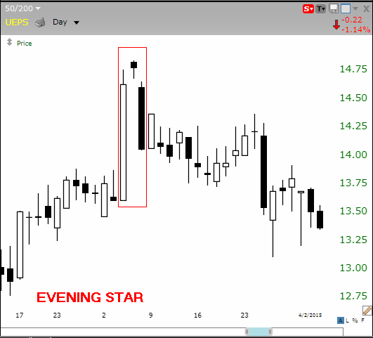**

**The bearish evening star reversal pattern starts with a tall white bar that carries an uptrend to a new high. The market gaps higher on the next bar, but fresh buyers fail to appear, yielding a** [**narrow range**](http://www.investopedia.com/terms/r/rangeboundtrading.asp) **candlestick. A gap down on the third bar completes the pattern, which predicts that the decline will continue to even lower lows, perhaps triggering a broader-scale downtrend. According to Bulkowski, this pattern predicts lower prices with a 72% accuracy rate. (See also:** [***How Is an Evening Star Pattern Interpreted by Analysts and Traders?***](http://www.investopedia.com/ask/answers/121014/how-evening-star-pattern-interpreted-analysts-and-traders.asp)**)**

## **Abandoned Baby**

**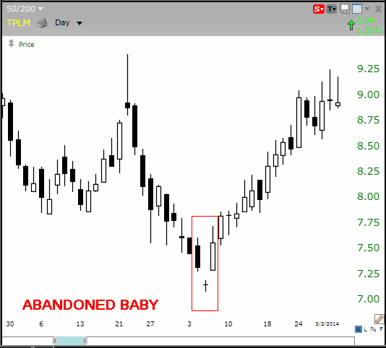**

**The bullish abandoned baby reversal pattern appears at the low of a downtrend, after a series of black candles print lower lows. The market gaps lower on the next bar, but fresh** [**sellers**](http://www.investopedia.com/terms/s/seller.asp) **fail to appear, yielding a narrow range doji candlestick with opening and closing prints at the same price. A bullish gap on the third bar completes the pattern, which predicts that the recovery will continue to even higher highs, perhaps triggering a broader-scale uptrend. According to Bulkowski, this pattern predicts higher prices with a 70% accuracy rate. (For more, see** [***Using Bullish Candlestick Patterns to Buy Stocks***](http://www.investopedia.com/articles/active-trading/062315/using-bullish-candlestick-patterns-buy-stocks.asp)**.)**

## **The Bottom Line**

**Candlestick patterns capture the attention of market players, but many reversal and continuation signals emitted by these patterns don't work reliably in the modern electronic environment. Fortunately, statistics by Thomas Bulkowski show unusual accuracy for a narrow selection of these patterns, offering traders** [**actionable**](http://www.investopedia.com/terms/a/actionable.asp)[**buy**](http://www.investopedia.com/terms/b/buy-signal.asp) **and** [**sell signals**](http://www.investopedia.com/terms/s/sell-signal.asp)**. (To learn more, take a look at** [***Advanced Candlestick Patterns***](http://www.investopedia.com/articles/trading/06/advcandlesticks.asp)**.)**

## **sland Reversal Patterns**

[**Island reversals**](http://www.investopedia.com/terms/i/islandreversal.asp) **are strong short-term trend** [**reversal**](http://www.investopedia.com/terms/r/reversal.asp) **indicators. They are identified by a gap between a reversal candlestick and two candles on either side of it. Here are two examples that occurred on the chart of Doral Financial (DRL).**

|  |
| --- |
| **AT_AdvdCandlesticks_V2_1r.gif**  **Figure 1** |

|  |
| --- |
| **AT_AdvdCandlesticks_V2_2r.gif**  **Figure 2** |

**Here are some important things you need to consider when using this pattern:**

* **Entry: Confirming the reversal pattern – When looking for an island reversal, you are looking for indecision and a battle between bulls and bears. This type of scenario is best characterized by a long-ended** [**doji**](http://www.investopedia.com/terms/d/doji.asp) **candle that has high volume occurring after a long prior trend; it is important to look for these three elements to confirm any potential reversal pattern.**
* **Exit: Defining the target and stop – In most cases, you will see a sharp reversal (as seen in Figs. 1 and 2) when using this pattern. This reversal pattern does not necessarily indicate a medium- or long-term reversal, so it would be prudent to exit your position after the** [**swing**](http://www.investopedia.com/terms/s/swing.asp) **move has been made. If the next candle ever fills the gap, then the reversal pattern is invalidated, and you should exit prudently.**

**Island reversals can also occur in "clusters" – that is, in a multi-candle reversal pattern, such as an** [**engulfing**](http://www.investopedia.com/terms/b/bearishengulfingp.asp)**, as opposed to a single candle reversal. Clusters are easier to spot, but they often result in weaker reversals that are not as sharp and take longer to occur.**

## **Hook Reversal Patterns**

[**Hook reversals**](http://www.investopedia.com/terms/h/hookreversal.asp) **are short- to medium-term reversal patterns. They are identified by a higher low and a lower high compared to the previous day. Figures 3 and 4 are two examples that occurred on the chart of Microsoft Corp. (MSFT).**

|  |
| --- |
| **AT_AdvdCandlesticks_V2_3r.gif**  **Figure 3** |

|  |
| --- |
| **AT_AdvdCandlesticks_V2_4r.gif**  **Figure 4** |

**There are several important things to remember when using this pattern:**

* **Entry: Confirming the reversal pattern – If the pattern occurs after an** [**uptrend**](http://www.investopedia.com/terms/u/uptrend.asp)**, then the open must be near the prior high, and the low must be near the prior low. If the pattern occurs after a** [**downtrend**](http://www.investopedia.com/terms/d/downtrend.asp)**, then the opposite is true. As with the island reversal pattern, we are also looking for high volume on this second candle. Finally, the stronger the prior trend, the more reliable the reversal pattern.**
* **Exit: Defining the target and stop - In most cases, you will see a sharp reversal (as seen in Figs. 3 and 4) when using this pattern. If the next candle shows a strong continuation of the prior trend, then the reversal pattern is invalidated, and you should exit quickly, but prudently.**

## **San-Ku (Three Gaps) Patterns**

[**San-ku patterns**](http://www.investopedia.com/terms/s/sanku.asp) **are anticipatory trend reversal indicators. In other words, they do not indicate an exact point of reversal; rather, they indicate that a reversal is likely to occur in the near future. They are identified by three gaps within a strong trend. Here is an example that occurred on the chart of Microsoft Corp. (MSFT).**

|  |
| --- |
| **AT_AdvdCandlesticks_V2_5r.gif**  **Figure 5** |

**Here are some important things to remember when using this pattern:**

* **Entry: Confirming the reversal pattern – This pattern operates on the premise that prices are likely to retreat after sharp moves because** [**traders**](http://www.investopedia.com/terms/t/trader.asp) **are likely to start booking profits. Therefore, this pattern is best used with other** [**exhaustion**](http://www.investopedia.com/terms/e/exhaustion.asp) **indicators. So, look for extremes being reached in indicators such as the** [**RSI**](http://www.investopedia.com/terms/r/rsi.asp) **(relative strength index),** [**MACD**](http://www.investopedia.com/terms/m/macd.asp) **(moving average convergence divergence)** [**crossovers**](http://www.investopedia.com/terms/c/crossover.asp)**, and other such indicators. It is also useful to look for volume patterns that suggest exhaustion.**
* **Exit: Defining the target and stop – In most cases, when using this pattern, you will see a price reversal shortly after the third gap takes place (as seen in Fig. 5). However, if there are any** [**breakouts**](http://www.investopedia.com/terms/b/breakout.asp) **on high volume after the last gap, then the pattern is invalidated, and you should exit quickly, but prudently.**

## **Kicker Patterns**

[**Kicker patterns**](http://www.investopedia.com/terms/k/kickerpattern.asp) **are some of the strongest, most reliable candlestick patterns. They are characterized by a very sharp reversal in price during the span of two candlesticks. Here's an example that occurred on the Microsoft (MSFT) chart.**

|  |
| --- |
| **AT_AdvdCandlesticks_V2_6r.gif**  **Figure 6** |

**Here are some important things you need to remember when using this pattern:**

* **Entry: Confirming the reversal pattern – This kind of price action tells you that one group of traders has overpowered the other (often as a result of a fundamental change in the company), and a new trend is being established. Ideally, you should look for a gap between the first and second candles, along with high volume.**
* **Exit: Defining a target and stop – When using this pattern, you will see an immediate reversal, which should result in an overall trend change. If the trend instead moves sideways or against the reversal direction, then you should exit quickly, but prudently.**

## **Using Gaps with Candlesticks**

**When gaps are combined with** [**candlestick**](http://www.traderslaboratory.com/forums/trading-dictionary/11769-candlestick-charting.html) **patterns and volume, they can produce extremely reliable signals. Here is a simple process that you can use to combine these powerful tools:**

|  |
| --- |
| 1. **Screen for breakouts using your software or website of choice.** 2. **Make sure that the breakouts are high volume and significant (in terms of length).** 3. **Watch for reversal candlestick patterns (such as the ones mentioned above) after the gap has occurred. This will typically happen within the next few bars, especially if the bars are showing indecision after a long trend.** 4. **Take a position when such a reversal occurs.** |

**Attempting to play reversals can be risky in any situation because you are trading against the prevailing trend. Do make sure that you keep tight stops and only enter positions when trades meet the exact criteria.**

## **The Bottom Line**

**Now you should have a basic understanding of how to find reversals using advanced candlestick patterns, gaps and volume. The patterns and strategies discussed in this article represent only a few of the many candlestick patterns that can help you better understand price action, but they are among the most reliable.**